**SRM INSTITUTE OF SCIENCE AND TECHNOLOGY**

**Department of Electronics and Communication Engineering**

**Laboratory Report Cover Sheet**

**18ECC303J – COMPUTER COMMUNICATION NETWORKS**

### **EVEN SEM 2022-23**

Name :

Section :

Venue :

Experiment title : Simulation of token bus protocol and to study the performance.

|  |  |  |
| --- | --- | --- |
| **PARTICULARS** | **MAX MARKS** | **MARKS OBTAINED** |
| Pre lab & Post lab | 10 |  |
| Lab performance | 15 |  |
| Record | 05 |  |
| Viva | 10 |  |
| Total | **40** |  |

**Report Verification**

Staff Name:

Signature with date:

**2. Simulation of token bus protocol and to study the performance.**

* 1. **Introduction**:

The purpose of this experiment is to understand the concept of demand assignment versus random access, setting priorities and token management in a bus LAN. In this lab you will be able to implement a token –passing access method for a bus LAN.

* 1. **Hardware Requirement**
* 3PCs with NIU card
* Network Emulation Unit
* Jumper Cables
  1. **Background**

**Token Bus** is a popular standard for token passing LANs. In a token bus LAN, the physical media is a bus or a tree, and a logical ring is created using coaxial cable. The token is passed from one user to another in a sequence (clockwise or anticlockwise). Each station knows the address of the station to its “left” and “right” as per the sequence in the logical ring. A station can only transmit data when it has the token.

A token is a small message that circulates among the stations of a computer network providing permission to the stations for transmission. If a station has data to transmit when it receives a token, it sends the data and then passes the token to the next station; otherwise, it simply passes the token to the next station.

###### Pre Lab Questions

1. What is meant by backbone in a network?
2. Give the advantages of token bus architecture.
3. What is token passing
4. Give the IEEE standard of token bus LAN.
5. Give the frame format of IEEE 802.4.

###### Procedure

**3.5.1 Token Bus**

1. Click on the Token Bus icon twice from the desktop.
2. Click the Configuration button in the window in both the PC’s.

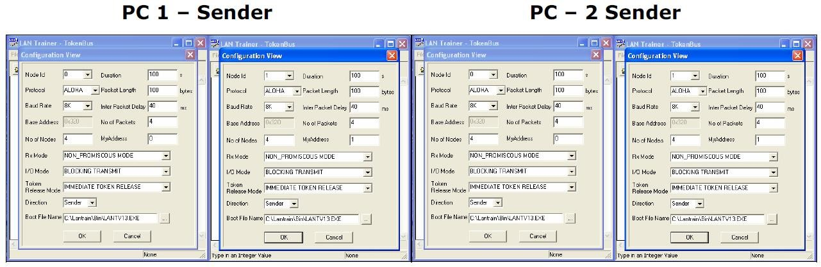

Setting the Configurations Menu for Token Bus

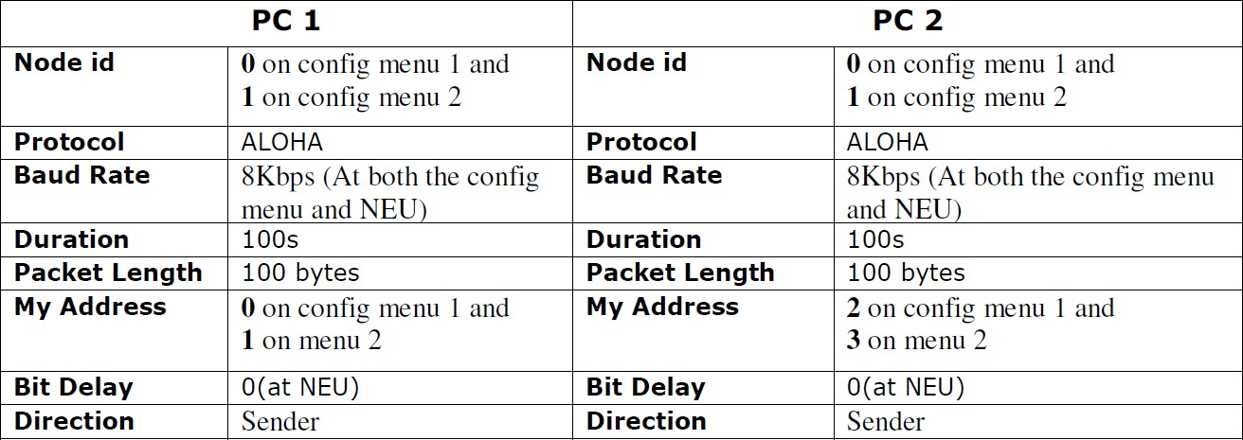

1. If you connect two PC’s and configured four nodes then set the My Address as 0 to 3 in all four nodes, if you connect three PCs and configured six nodes then set the My Address as 0 to 5 in all six nodes.
2. Start running the experiment from the lowest priority node (i.e., from My Address 3 in case of four nodes and 5 in the case of six nodes)
3. No of Nodes has to be set as 4 when two PCs are connected and 6 when three PCs are connected.

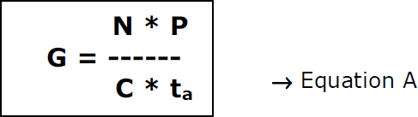

G is the generated load in the network.

N is the number of nodes participating in the network. For example, let us say that 4 nodes (using 2 computers)

P is the packet length expressed in bits; say 100 bytes (800 bits).

C is the data rate normally set as 8kbs, which is selected in the NEU.

ta is the inter packet delay expressed in seconds; the time interval between two consecutive packets generated.

So, lets assume ta = 40 milliseconds and substitute the above mentioned parameters in the Equation A which leads to G = 10. Like wise assume various values of ta to generate offer loads in the range of 0.1 to 10. Substitute the value of ta in the configuration menu.

1. Click OK button and Download the driver to the NIU using the BOOT button  command.

Booting from any one of the applications is enough.

1. Run the experiment by clicking button or by choosing RUN _ Start from each application.

Run the all the experiments at the same time.

Note: While you do this THT window pops up, enter the THT time in all nodes and press the OK button first in the node, which has the lowest priority of My Address.

1. Set the Token Holding Time (THT) (say 10000 ms).
2. 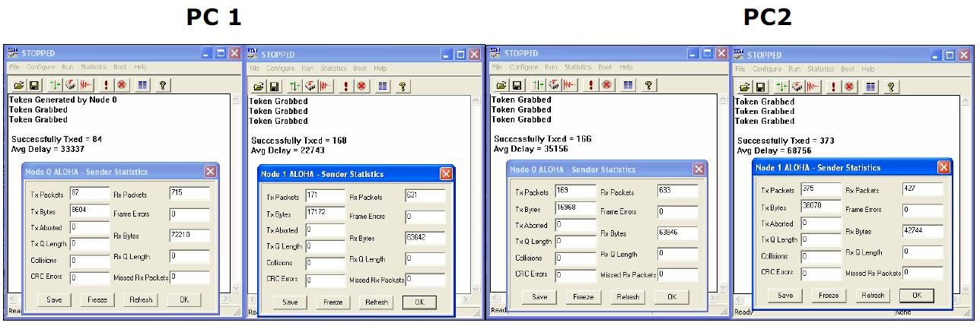View Note down the readings once the experiment is completed.
3. Repeat the above steps for various values of ta
4. Calculate the Practical offered load from the below given formula and plot the graph between the practical Offered load and Throughput.

Note: You can also use the template for plotting the graph. Please refer Appendix-1 to plot the graph using the template.

1. Repeat the experiment for various values of Packet length, Node, Data rate.
2. Repeat the above steps, while running the experiment set the BER to 10-2 in the NEU or try to stop one of the nodes and observe the behavior and explain the same.

Calculations of Practical Throughput from the obtained readings

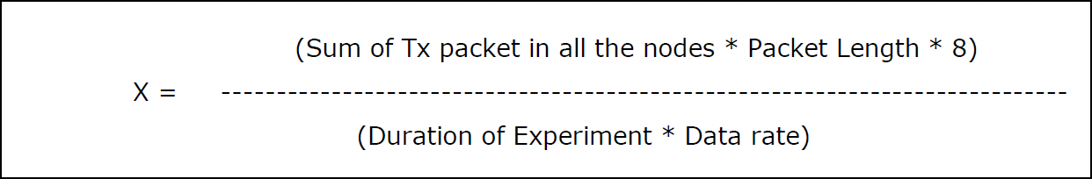

Calculations of Offered Load

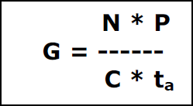

G – Offered load

N – Number of nodes

P – Packet length in bits

1. the statistics window for results. To view the statistics window click on button.
2. Note down the readings once the experiment is completed.
3. Repeat the above steps for various values of ta
4. Calculate the Practical offered load from the below given formula and plot the graph between the practical Offered load and Throughput.

Note: You can also use the template for plotting the graph. Please refer Appendix-1 to plot the graph using the template.

1. Repeat the experiment for various values of Packet length, Node, Data rate.
2. Repeat the above steps, while running the experiment set the BER to 10-2 in the NEU or try to stop one of the nodes and observe the behavior and explain the same.

Calculations of Practical Throughput from the obtained readings



Calculations of Offered Load



G – Offered load

N – Number of nodes

P – Packet length in bits

C – Data rate in bits/sec

ta -Inter packet delay in millisecs.

Model Tabulations

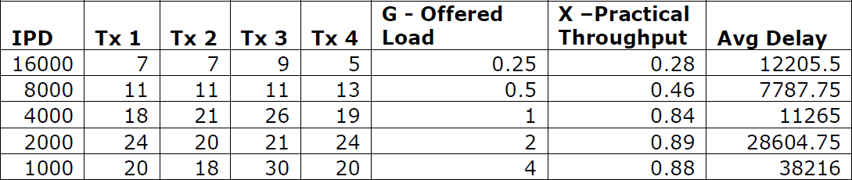

Model Graph

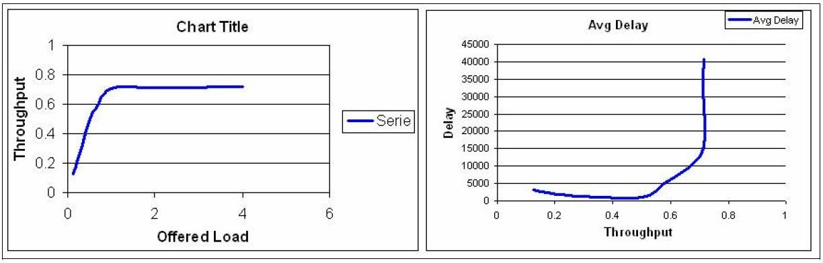

###### Post lab questions:

1. What are lost tokens?
2. What is the use of preamble?
3. What is check sum? What is it used for?
4. What is token holding time?
5. What is token rotation time?

###### Result:

Thus, token bus protocol is simulated and its performance is studied